Session 2026-2027

Vision:Dream of where you want. | Mission: Means to achieve Vision

Program Educational Objectives of the program (PEO): (broad statements that describe the professional and career accomplishments)
PEO1 | Preparation | P: Preparation | Pep-CL abbreviation  pronounce as Pep-si-lL easy to recall
PEO2 | Core Competence | E: Environment (Learning Environment) | Pep-CL abbreviation  pronounce as Pep-si-lL easy to recall
PEO3 | Breadth | P: Professionalism | Pep-CL abbreviation  pronounce as Pep-si-lL easy to recall
PEO4 | Professionalism | C: Core Competence | Pep-CL abbreviation  pronounce as Pep-si-lL easy to recall
PEO5 | Learning Environment | L: Breadth (Learning in diverse areas) | Pep-CL abbreviation  pronounce as Pep-si-lL easy to recall

Program Outcomes (PO): (statements that describe what a student should be able to do and know by the end of a program)
Keywords of POs:
Engineering knowledge,Problem analysis, Design/development of solutions,Conduct Investigations of Complex Problems, Engineering Tool Usage, The Engineer and The World,Ethics, Individual and Collaborative Team work,Communication, Project Management and Finance, Life-Long Learning

PSO Keywords: Cutting edge technologies, Research

“I am an engineer, and I know how to apply engineering knowledge to investigate, analyse and design solutions to complex problems using tools for entire world following all ethics in a collaborative way with proper management skills throughout my life.” to contribute to the development of cutting-edge technologies and Research.

Integrity: I will adhere to the Laboratory Code of Conduct and ethics in its entirety.

Name and Signature of Student and Date
(Signature and Date in Handwritten)

Session | 2024-25 (ODD) |  | Course Name | Web Technology Lab
Semester | 3 |  | Course Code | 23CT1301
Roll No | 57 |  | Name of Student | Prasun Kachhwah
Practical Number |  | 2
Course Outcome |  | - Understand various internet technologies.  - Design the web pages using HTML and CSS.  - Implement the XML technology to store the data.  - Develop the interactive web pages using JavaScript.
Aim |  | Create a web form by using form tags in HTML
Problem Definition |  | Making a Student Registration Form in HTML using the form controls such as text boxes, radio buttons, checkboxes, text areas, drop-down menus, file upload, and action buttons.
Theory  (100 words) |  | HTML forms collect user input and submit it to a server or process it locally. Key elements include:  - <form>: The container element for all input components.  - <input>: A flexible tag whose type attribute determines the control (e.g., text, date, radio, checkbox, file, password, submit, reset).  - <textarea>: A multi-line text field for entering details like addresses.  - <select> and <option>: Creates drop-down selection menus.
Procedure and Execution  (100 Words) |  | Step for Implementation:  Open a text editor (such as VS Code, Notepad, or Notepad++).  - Create a file named student_registration.html.  - Add the basic HTML boilerplate structure (<html>, <head>, <title>, <body>).  - Add a centered title heading using <h1>.  - Enclose all input elements inside a <form> block.  - Include inputs for text fields (Name, Email, Mobile), date pickers (DOB), radio options (Gender), checkboxes (Hobbies), drop-down lists (Course selection), file attachments, and passwords.  - Add Submit and Reset buttons at the bottom.  - Open the .html file in a web browser to verify layout and form interaction.
Code:
<!DOCTYPE html>
<html lang="en">
<head>
<meta charset="UTF-8">
<meta name="viewport" content="width=device-width, initial-scale=1.0">
<title>Student Registration Form</title>
<style>
body {
font-family: Arial, sans-serif;
background-color: #f4f7f6;
margin: 0;
padding: 40px 20px;
}

.form-card {
max-width: 500px;
margin: 0 auto;
background: #ffffff;
padding: 30px;
border: 1px solid #e0e0e0;
border-radius: 8px;
}

h1 {
text-align: center;
}

.form-group {
margin-bottom: 16px;
}

label {
display: block;
font-weight: bold;
margin-bottom: 6px;
color: #444444;
}

</style>
</head>
<body>

<div class="form-card">
<h1>Student Registration Form</h1>
<form>
<div class="form-group">
<label for="fname">First Name:</label>
<input type="text" id="fname">
</div>

<div class="form-group">
<label for="lname">Last Name:</label>
<input type="text" id="lname">
</div>

<div class="form-group">
<label for="dob">Date of Birth:</label>
<input type="date" id="dob">
</div>

<div class="form-group">
<label>Gender:</label>
<div class="inline-group">
<label><input type="radio" name="g" value="male"> Male</label>
<label><input type="radio" name="g" value="female"> Female</label>
<label><input type="radio" name="g" value="other"> Other</label>
</div>
</div>

<div class="form-group">
<label for="email">Email:</label>
<input type="email" id="email">
</div>

<div class="form-group">
<label for="mobile">Mobile:</label>
<input type="tel" id="mobile">
</div>

<div class="form-group">
<label for="address">Address:</label>
<textarea id="address" rows="4"></textarea>
</div>

<div class="form-group">
<label for="course">Course:</label>
<select id="course">
<option value="bca">BCA</option>
<option value="bsc">B.Sc</option>
<option value="bcom">B.Com</option>
<option value="btech">B.Tech</option>
<option value="ba">BA</option>
</select>
</div>

<div class="form-group">
<label>Hobbies:</label>
<div class="inline-group">
<label><input type="checkbox" value="reading"> Reading</label>
<label><input type="checkbox" value="sports"> Sports</label>
<label><input type="checkbox" value="music"> Music</label>
<label><input type="checkbox" value="dancing"> Dancing</label>
</div>
</div>

<div class="form-group">
<label for="photo">Upload Photo:</label>
<input type="file" id="photo">
</div>

<div class="form-group">
<label for="password">Password:</label>
<input type="password" id="password">
</div>

<div class="button-group">
<input type="submit" value="Register">
<input type="reset" value="Clear">
</div>
</form>
</div>

</body>
</html>
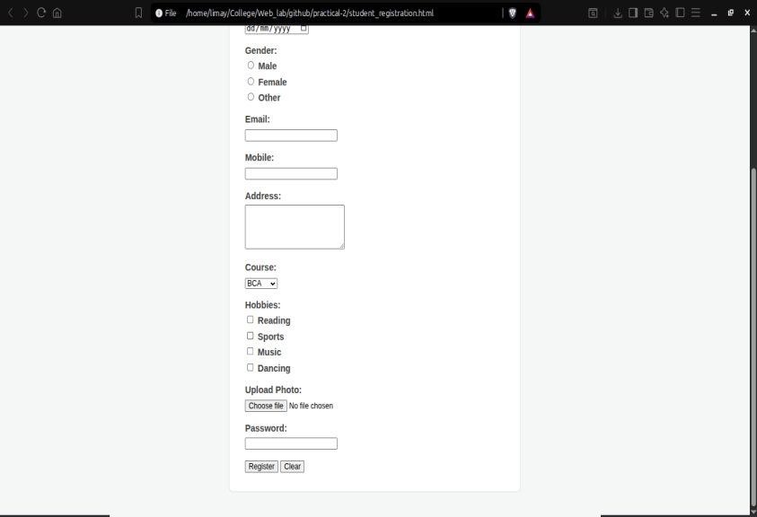
Output: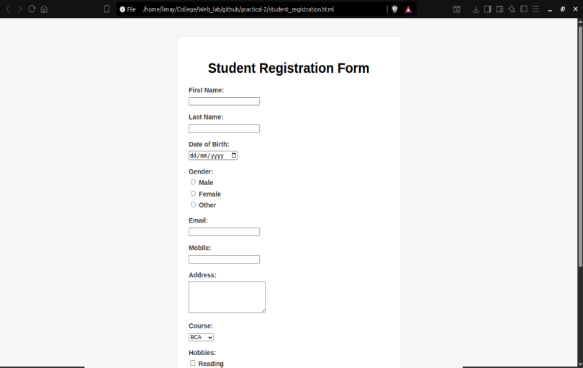
Output Analysis |  | Centered page title: Student Registration Form.  Form fields displayed sequentially: First/Last Name text boxes, Date selector, Gender radio buttons, Email/Mobile inputs, multi-line Address text area, Course dropdown menu, Hobby checkboxes, File upload button, and masked Password box.  - Interactive Register and Clear buttons at the bottom
Link of student Github profile where lab assignment has been uploaded |  | https://github.com/PrasunKachhwah
Conclusion |  | The student registration web page was successfully constructed, displayed using standard HTML form tags, and verified in the browser.
Plag Report (Similarity index < 12%) |  | 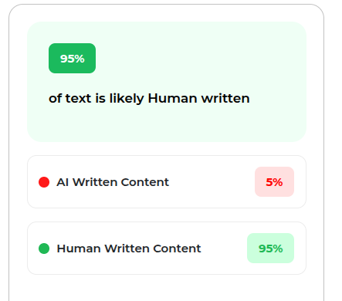
Date |  | 14/07/2026

